- New Directory –
- populate it with script files, initiate an empty repository on GitHub
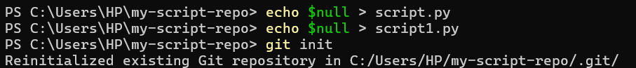
- convert the local directory into a Git repository, and link it to GitHub for pushing the code into the repository
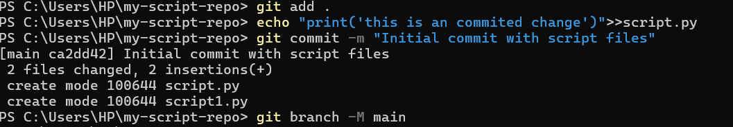
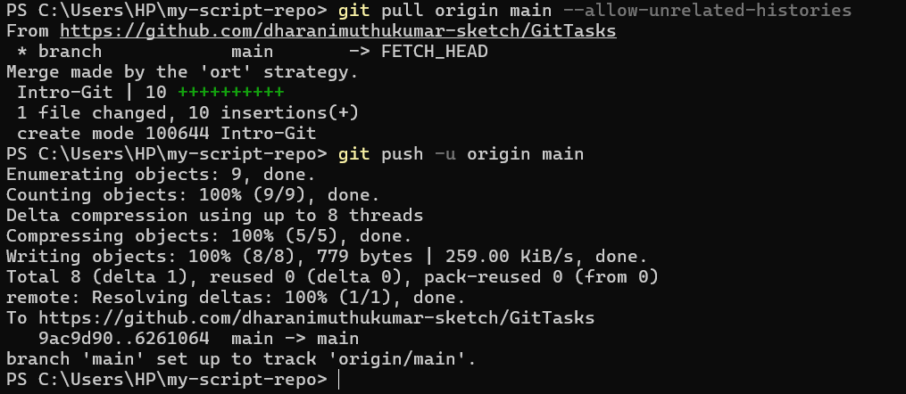
- Perform merge, rebase, stash commands in following github repo.
Merge –
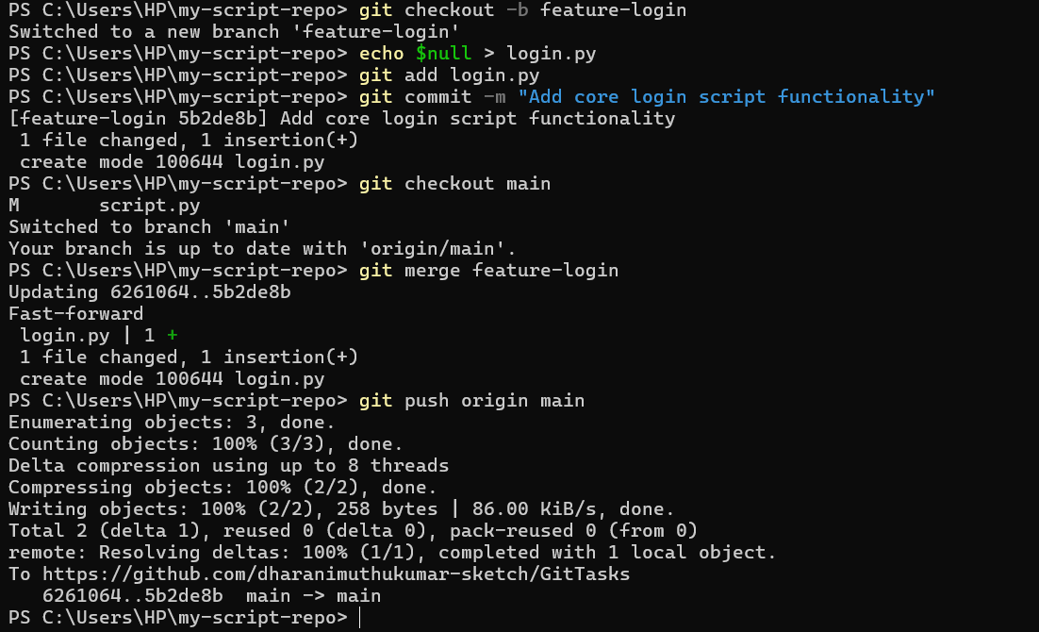

Stash - 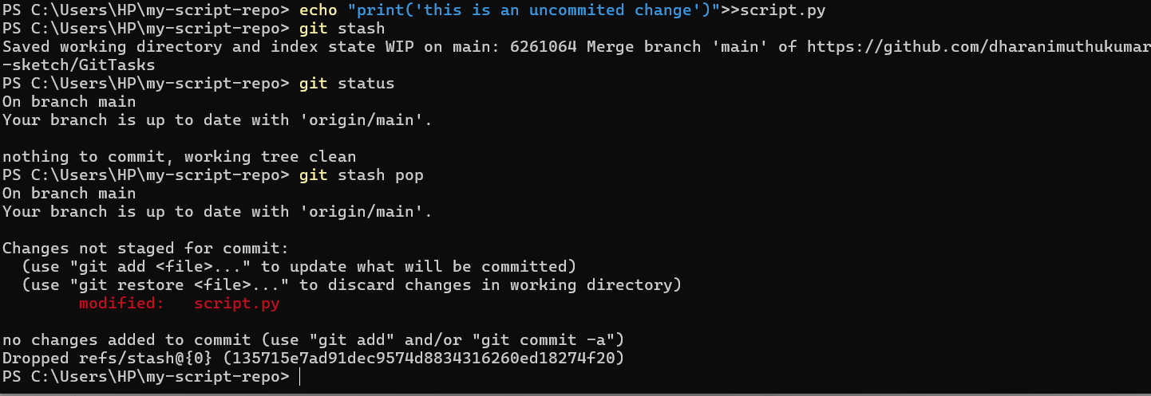
Rebase –
